Module Four Exercise

Proactive Identification of Losses

Michael Surdek
Southern New Hampshire University
DAT 610: Optimazation & Risk Assessment
Professor Kyle Camac
November 7, 2021

Introduction

Company XYZ, a provider of property & casualty insurance coverage, is experiencing greater operational losses than they had expected, seemingly due to fraudelent injury claims from automobile accidents. For this reason, they have decided to bolster their operational risk program, with the hopes of creating a high-level function alongside their existing market, credit, and insurance risk programs. The company has an industry-standard special investigations unit (SIU) in place, but it is understaffed and overwhelmed by a high volume of these auto accident bodily injury claims. The main goal of the operational risk program is to support the SIU through data analytics. Company XYZ maintains an internal loss dataset that contains information on past individual claims such as the amounts claimed and eventually paid, a suspicion score, and 20 metrics indicative of fraud as well as the RIDIT transformations of each metric. Through the capabilities of programming in R, they can effectively analyze this dataset to determine factors that signal potential fraud and therefore improve their investigative processes and strategy.

Description of the PRIDIT Scoring Method
PRIDIT analysis is a two step “unsupervised, nonparametric, aggregation technique” (Lieberthal, 2008) which results in relative rankings of an output variable based on various combinations of input variables. Company XYZ is looking to rank the suspiciousness of future claims based on what the 20 indicative metrics tell them about the likelihood of a claim being fraudelent in their dataset.
The first step of PRIDIT analysis is to generate uniform scores for otherwise ordinal metrics, called RIDITs. RIDIT transformation is a useful technique when values are quanitfied on a subjective scale. In the case of Company XYZ’s indicative metrics, the actual value of the variable is less important than its position in relation to the rest of the observations. By using the RIDIT approach, these metrics can be analyzed “based on the observed distribution of a response variable for a specified set of indivudals” (Bross, 1958), which allows for more accurate modelling and predictions.
The second step of PRIDIT is to reduce the dimensionality of the 20 RIDIT variables by using Principal Component Analysis (PCA). PCA identifies combinations of discriminating factors based on variation and patterns within the data. For 20 indicative metrics, PCA returns 20 principal components, identified in ascending order 1 through 20 according to the amount of variability in the data that each component represents. For this reason, it is then possible to use just the first two components to visualize the analysis in two dimensions. Additionally, the indicative metrics can then be plotted along the two dimensions in order to determine how each metric correlates to the principal components and to the output variable of interest.
To go further with the analysis and to determine the effectiveness of the PRIDIT technique, the results can be explored according to their similarity with other methods of determining claim suspicion, such as the opinions of investigators or adjudicaters. “The PRIDIT technique provides several relevant output values that can be used to exogenously test the consistency of subjective rankings, or classification of claims, with fraud indicator data.” (Brockett, 2002) The output values from PRIDIT can be subjective ranks, bivariate class membership (fraud/non-fraud), or relationship/correlation scores to the various indicators. Each of these PRIDIT outputs can help determine the efectiveness of the analysis and compare it against other scoring methods.

Loading Data into R
The first step in most data analysis projects is loading and cleaning the dataset in the R environment. R provides the read-csv function to load the contents of a file into a dataframe object. Since the claims file included empty rows between each observation, the NA values must be removed so that the dataframe can be properly analyzed in a tidy format.
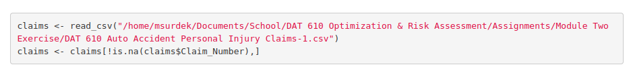

Evaluation of RIDIT-ized Transformations
As mentioned in the PRIDIT description section, the first step of PRIDIT analysis is to generate RIDIT transformations. The claims file provided already provides transformations of the 20 indicative metrics, so some simple analysis can verify these transformations. The following code uses the RIDIT formula to determine the RIDIT values when IND_01 is equal to 1, 2, or 5.
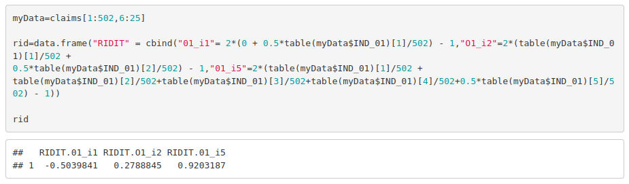
Taking a look at the RIDIT values in the dataset, it is clear that they were calculated according to the RIDIT formula above. RIDIT_01 is -0.504 when IND_01 is 1, 0.279 when IND_01 is 2, and 0.920 when IND_01 is 5.
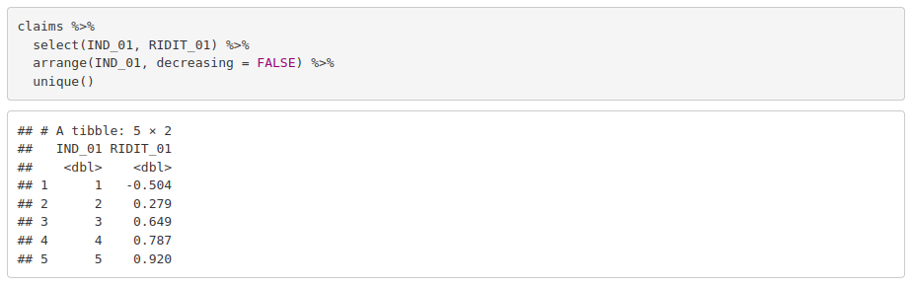
One more thing to explore before PCA is whether the RIDIT transformations result in the appropriate directionality for the PRIDIT scoring method. What this means is that as each IND metric increases, the corresponding RIDIT metric should also increase. That was the case for IND_01, but for confirmation of the other 19 indicators, the dataset must be pivotted into a longer form that contains 20 rows for each claim with both the IND and RIDIT value for each observation.

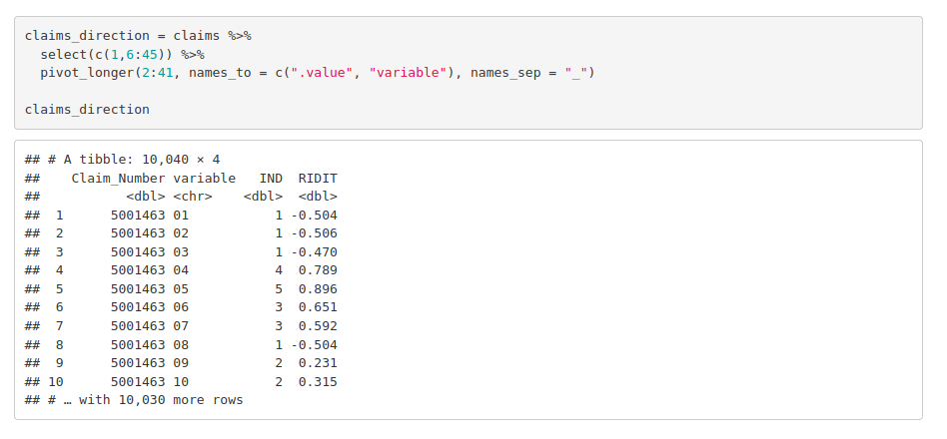
The transformed dataframe above can then be plotted to visualize the IND and RIDIT values for each of the 20 indicative metrics. The plots clearly show that each of the RIDIT transformations have resulted in the appropriate directionality for the PRIDIT scoring method.
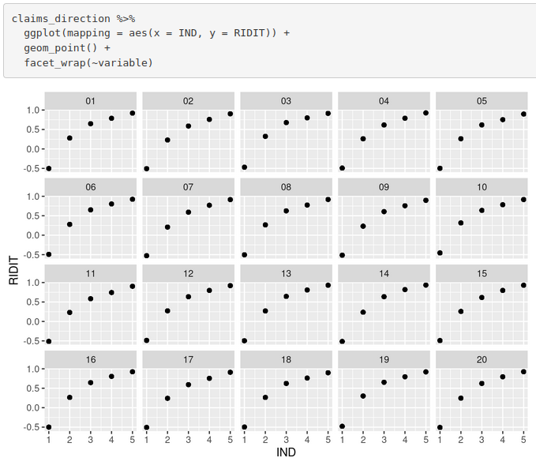

Principal Component Analysis
Now that the RIDIT transformations have been generated and confirmed, the next step in PRIDIT analysis is performing component analysis. As mentioned previously, this will result in 20 components that represent combinations of the RIDIT metrics for the purpose of identifying and ranking potentially fraudelent claims. The following code uses the princomp function to do the heavy lifting of calculating the components. We can take a closer look at the components with the summary function. This shows that the components are ordered according to the proportion of variance that they account for in descending order. The first component accounts for 6.7% of the total variation and the twentieth accounts for 3.3%. These seem like small amounts but it is not an unusual result with 20 indicative metrics. You can also see that the 20 components combine account for 100% of the variation, based on the cumulative proportion value of the twentieth component.

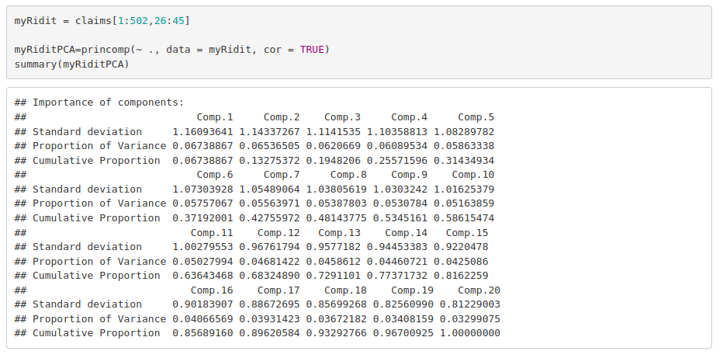
Visualization of Results
Using R to calculate the principal components and their relative importance provides the foundation for further analysis and statistical modelling, but additional insight can be derived from just the output of the princomp function as well as the results of the PCA function from the FactoMineR package. The screeplot function visualizes the information from the summary table above. The bar chart shows the variances accounted for by each of the first ten principal components.
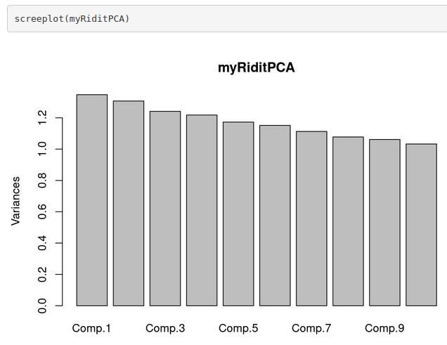
Additional helpful visualizations can be produced by the FactoMineR package. This package “provides functions for multivariate data analysis with the main issue to consider the structure of the data (if there is a partition on or a hierarchy of the variables, or if there is a partition on the observations) and the type of the variables (quantitative or categorical). A special focus also lies on supplementary information, that is information which is added after the analysis.” (Hoffman, 2011)
The benefits of using FactoMineR for PCA is the flexibility it provides for complex datasets, the ability to properly handle for quantitative and qualitative data, and to add supplementary information after the analysis. In Company XYZ’s case, they could perform PCA and then add their own claim suspicion scores to determine how the components correlate to the levels of potential fraud.
The following charts are created from the PCA function in the FactoMineR package. The first shows the location of the 502 observations along the two dimensions of the first two principal components. The second shows how each of the 20 indicator metrics contribute to the first two principal components themselves.

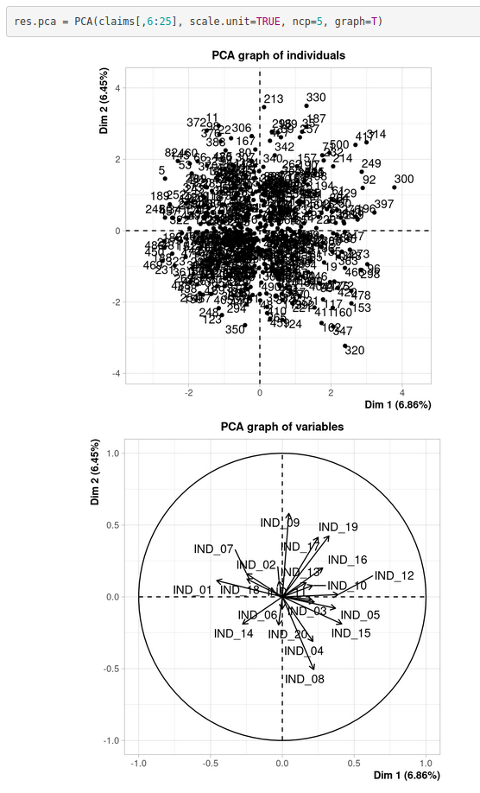
The first chart, for example, shows that observation #300 has approximate values of 3.9 along the first principal component and 1.2 along the second. The second chart, provides information such as the facts that the first principal component is most positively correlated with IND_15 and that the second principal component is most negatively correlated with IND_08.
Finally, as mentioned above that the FactoMineR package can handle supplementary information after the analysis, it is possible to include the claim suspicion scores from the dataset to observe how the first two principal components correlate to the overall likelihood of a fraudelent claim.
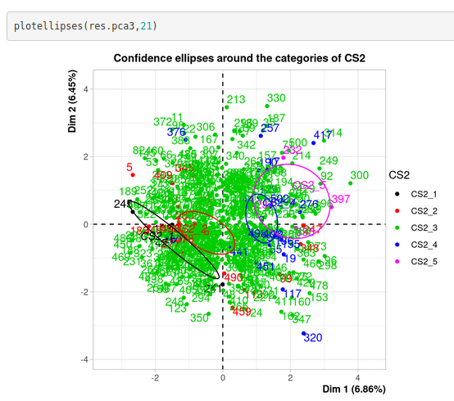
The ellipses represent a confidence interval of the estimated mean value of the first two principal components for each of the claim suspicion scores 1 through 5. The observations are also colored accordingly, so you can see the actual distribution of the various claim suspicion scores. Most of the observations have a claim suspicion score of 3, and there is no clear estimate of the mean principal component values for those individuals. However, claim suspicion scores of 1, 2, 4, and 5 have more defined boundaries and it can easily be seen how the likelihood of a fraduelent claim increases as the values of the first two principal components increase.

References

Brockett, P. L., Derrig, R. A., Golden, L. L., Levine, A., & Alpert, M. (2002). Fraud classification using principal component analysis of RIDITs. Journal of Risk and Insurance. Retrieved from https://eds-s-ebscohost-com.ezproxy.snhu.edu/eds/pdfviewer/pdfviewer?vid=1&sid=081e82b9- a410-4ab3-a874-ffe5f490acb3%40redis

Bross, Irwin D. J. (1958). How to Use Ridit Analysis. Biometrics, 14(1), 18–38. Retrieved from https://doi.org/10.2307/2527727

Hoffman, Irene. (2011.) Principal Component Analysis with FactoMineR. Institute of Statistics and Mathematical Methods in Economics and Applied Statistics. Retrieved from https://web.archive.org/web/20150824033748/http://www.statistik.tuwien.ac.at/public/filz/ students/seminar/ws1011/hoffmann_ausarbeitung.pdf

Lieberthal R. D. (2008). Hospital quality: a PRIDIT approach. Health services research. Retrieved from https://www.ncbi.nlm.nih.gov/pmc/articles/PMC2442235/

